

SUBMITTED TO AHMAD NADEEM SAEED

**Burn-Down Chart STAKEHOLDER AGILE METHODOLOGIES**

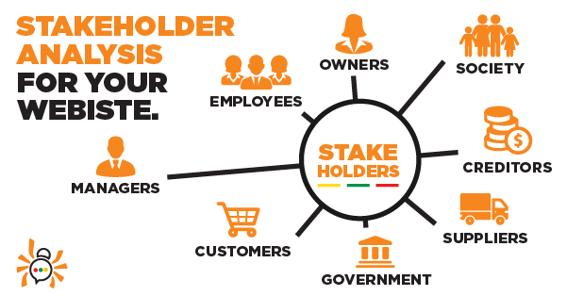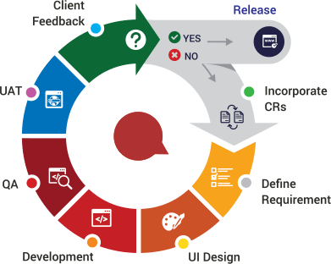

**ENTITY RELATION DIAGRAM DATA FLOW DIAGRAM**

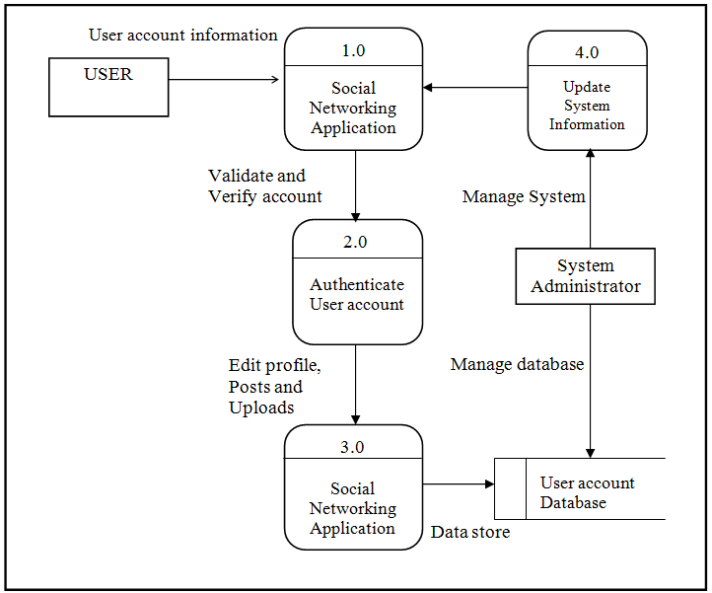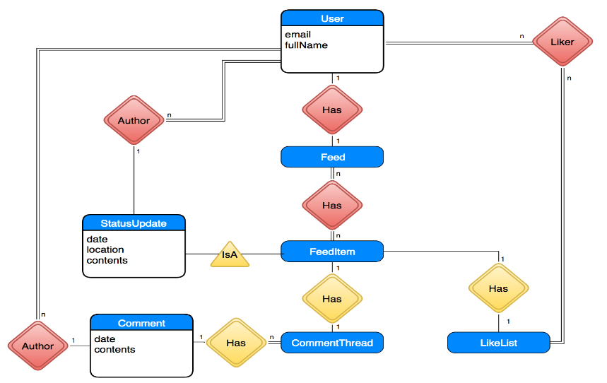

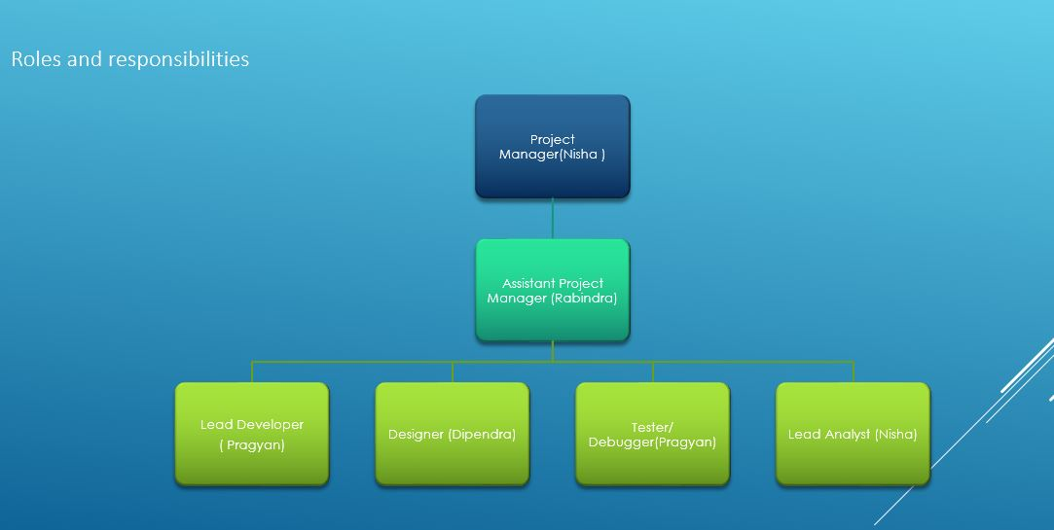

**Client Problems:**

**They want us to make more creative and fun kind with more interesting things.**

**Client Feedback:** Client was very happy with the website because it is very helpful for the new comer’s to abroad.

**Submitted By Group2:**

Nisha Prasai (30336119)

Rabindra Gurung (30335729)

Pragyan Karkee (30356375)

Dependra Thapa (30335012)

**WEBPAGE DEIGN FOR INTERNATIONAL IIBIT STUDENTS**

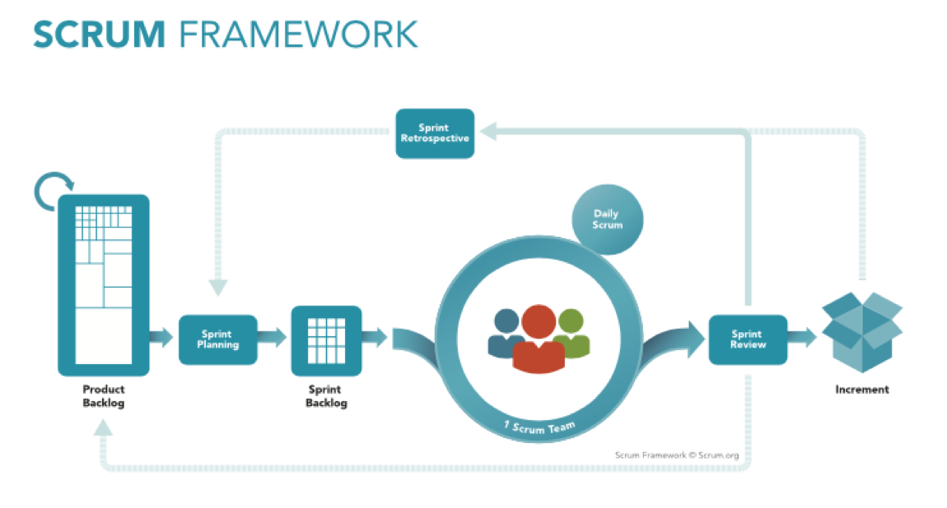

**SCRUM AND NON SCRUM**



SUBMITTED TO AHMAD NADEEM SAEED

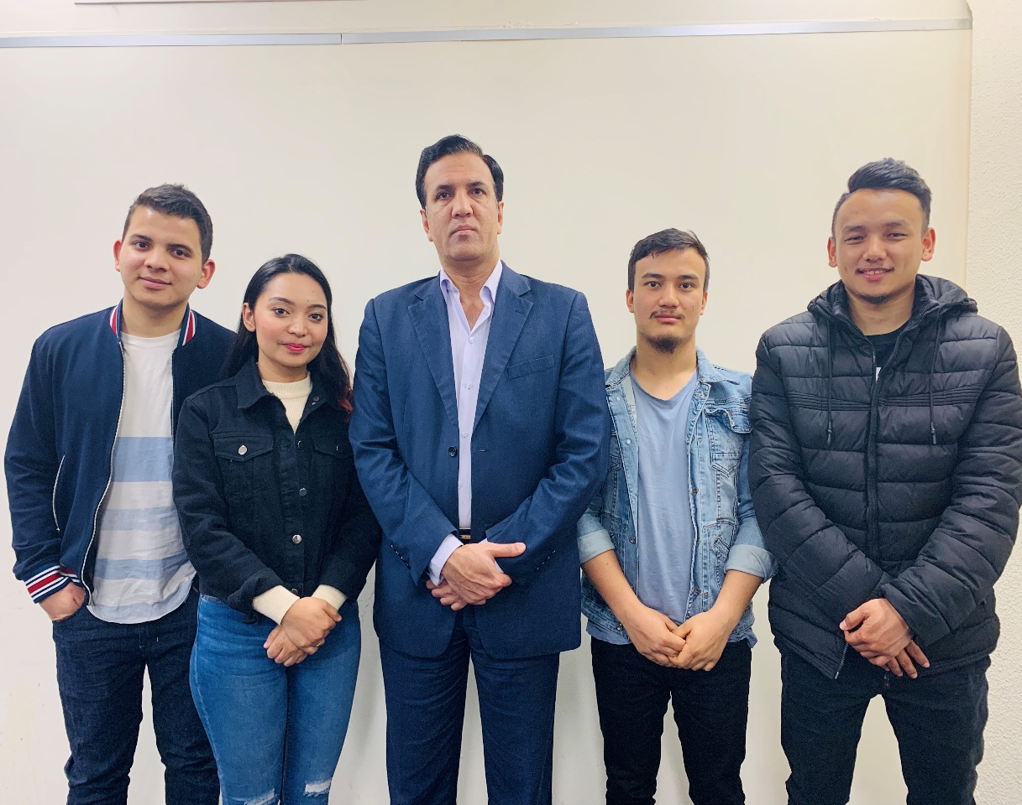

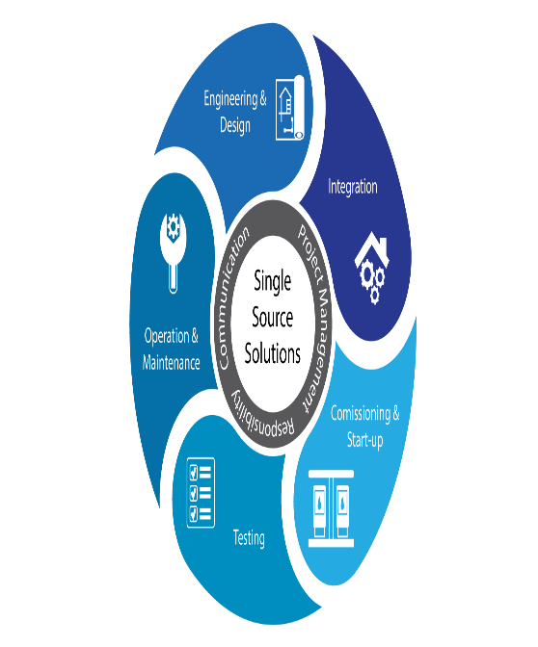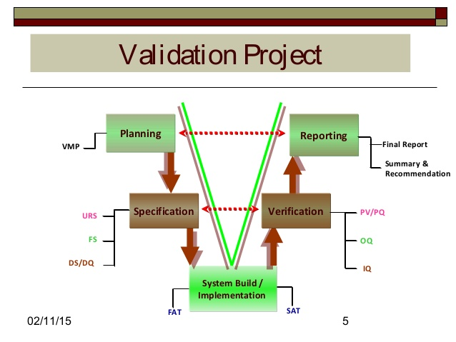

**WEBSITE PAGE PROJECT VALIDATION SOLUTION**

**Submitted By Group2:**

Nisha Prasai (30336119)

Rabindra Gurung (30335729)

Pragyan Karkee (30356375)

Dependra Thapa (30335012)